HR Data analytics at acme telco

Description of the data set:

The dataset contains three tables

Table1:

1.General HR information gathered from the HR information system l

Employee ID: Unique employee record number

Position: Role the employee held

DOB: Date of birth of the employee

Gender: Employee gender(male/female)

Marital status of the employee: (Divorced/single/married/widowed)

Date of hire: Date when the employee was hired by the company

Date of termination: If the employee has been termination the data on which they were

Termination reason: The reason why the employee left the organisation

Employee status: Whether the employee is currently with the company terminated

Table2:

1.Performance and employees satisfaction survey results gathered from the system ll

Employee ID: Unique employee record number

Dept: Which department the employee worked in

Manager name: Employees manager name

Perf score: Most recent employee performance rating

Emp sat: Employee satisfaction score

Date of the last perf review: Date on which the most recent performance review was conducted

Late days: Employee being late to the company

Absence: Employee being absent to the company

Table3:

1.Employee salary details gathered from the financial information system

Employee ID: Unique employee record number

Salary: Annual salary of the employee in USD

1.Preparing the data for tableau:

Before conducting any analysis in tableau, we need to first connect the data

Connecting:

1.connect tableau by selecting connect to a file and open Microsoft excel select file in it and the open

2.In this case since all sheets have equal number of rows and the employee ID is available in all sheets, we can do any type of join or data blending or combine using relationships

3.We will combine using relationships

4.HRIS-1 is the sheet that contains most information we will bring it first to the table section tableau will automatically use employee ID to connect the tables close the window and move forward to connect the sheet FIS

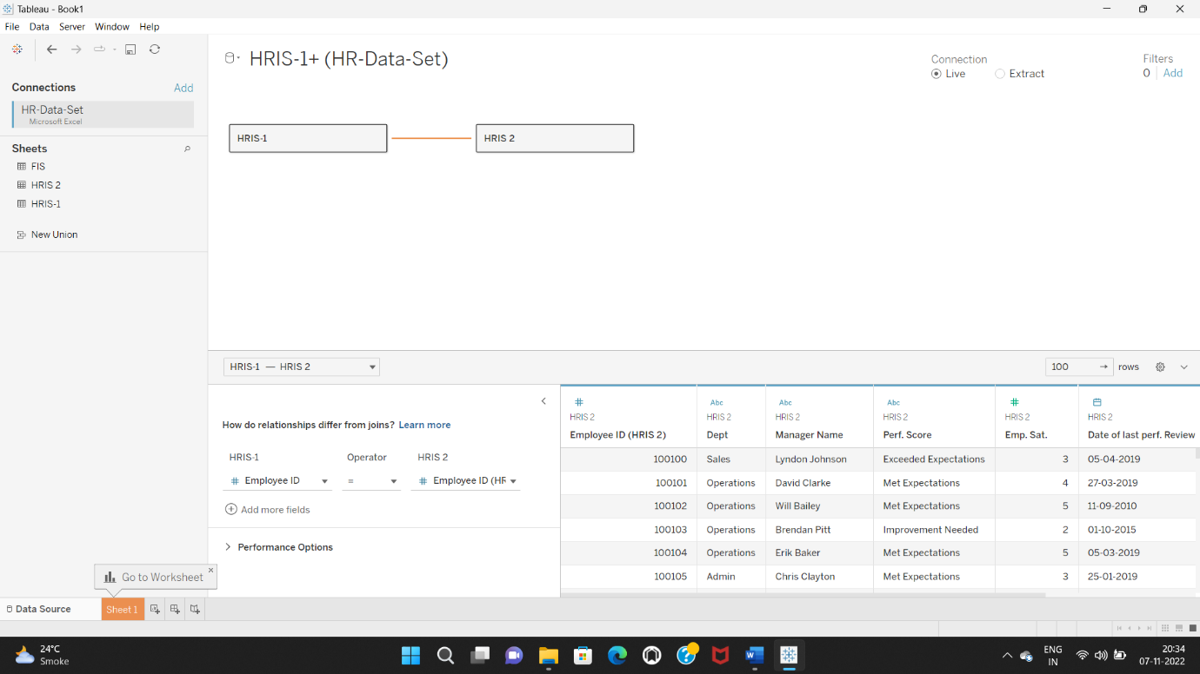

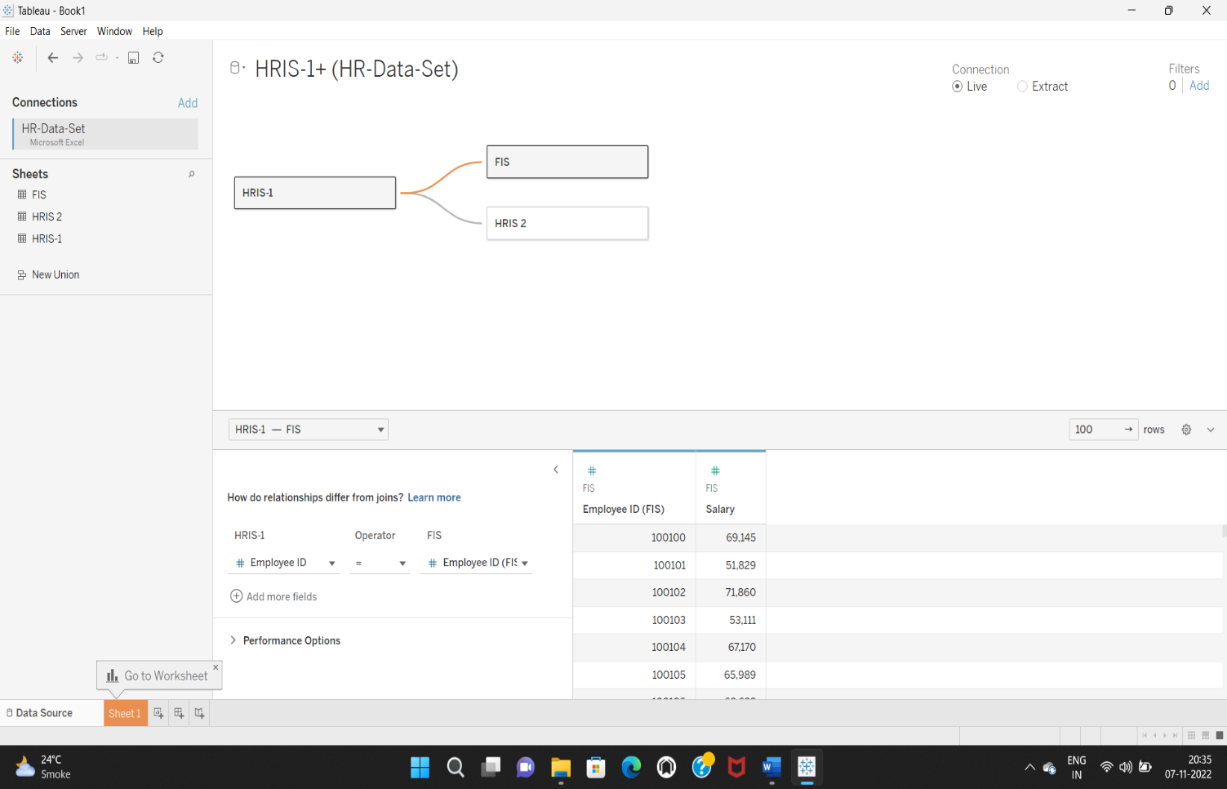

5.We will do a couple of steps to make the data more usable for future analysis this involves creating grouping the data the data is quite

2.Data clean up:

In this case, the data is quite clean ,we will do a couple of steps to make the data more usable for future analysis this involves creating grouping the data and creating hierarchies

1.Termination reasons are quite detailed so we will group them in to some high- level groups

* 1. a. career issues: career change, found a better job, went for higher paying job
  2. b. personal issues:Did not return from maternity, health, higher education, relocated, sabbatical
  3. 2. Positions are also quite many in the dataset, we can group the positions into senior management, middle management and employees
  4. a. Senior management:CEO / CIO/ Directors
  5. b. Middle management:Anyone with having ‘Manager’ in their job title
  6. c. Employees:everyone else

3.Employee status: we will combine ‘terminated for cause’ and ‘voluntarily terminated’ as one group called ‘terminated’

4.We will rename the original ‘Employment status’ field as ‘Termination type’. This will allow us to nest the two fields employment status and termination type together if we want

Visualizing HR data at acme:

We will prepare the charts and dashboards in the order of expectations laid out note that there is no one way in terms of what charts need to be used

Exploratory analysis:

1.Group size and demographics

a. How many employees are currently employed by employed by each department

1.Move dept to row and HRIS-1 to columns

2.Move employment status to filter and filter ‘active employees’

3.Show text labels

4.Sort the bar chart in the descending order

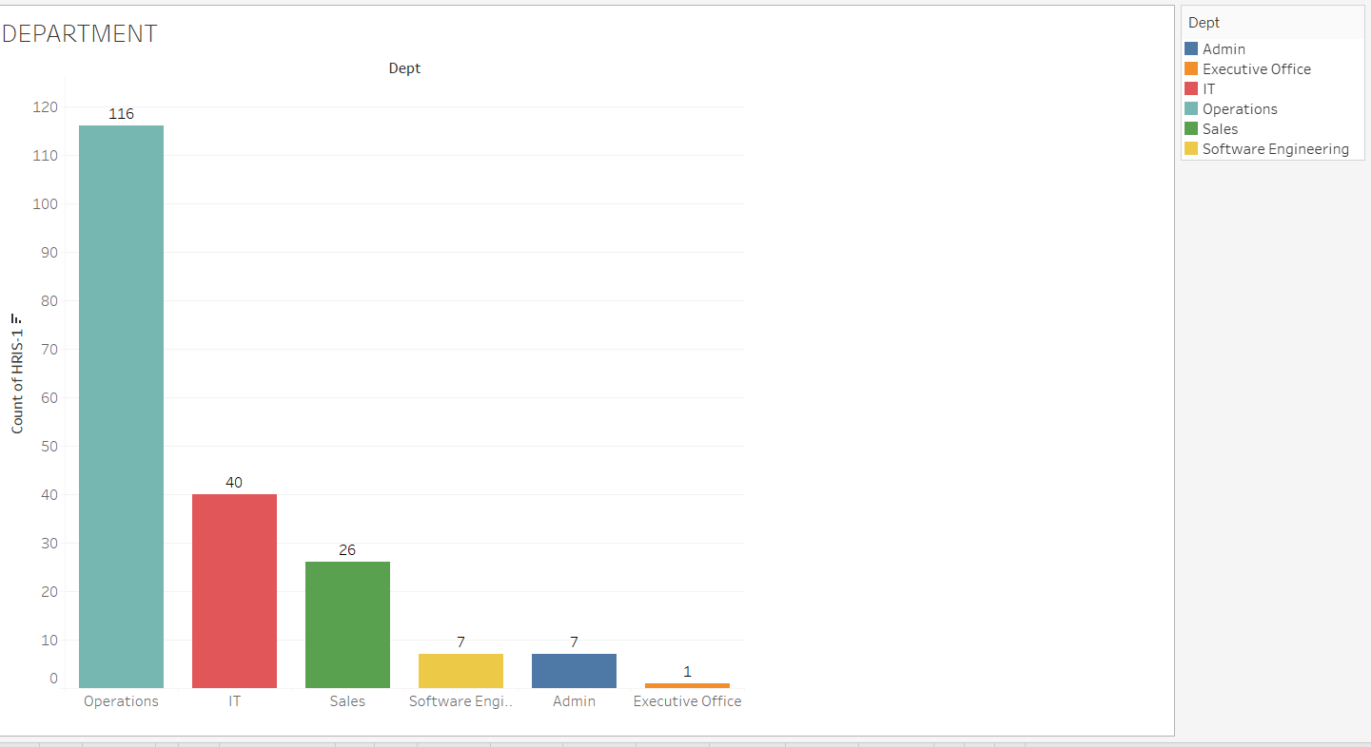

Insight:

The largest department is operations with 116 employees followed by IT, sales, admin, software engineering and executive office with 40,26,7,7 and 1 employee

b. What are the demographics of the current employees by age

1.Create a calculated field called ‘review date’ with text ’31-Dec- 2020

2.Create a calculated field to compute age ROUND (([Review date]-[DOB])/365,0)

This computes the days between DOB and the review date, convert in to nearest year

3.Create bins for the field ‘age’ with a bin size of 10 years

4.Bring ‘age(bin)’ to column and HRIS-1 count to row

5.Filter for active employees

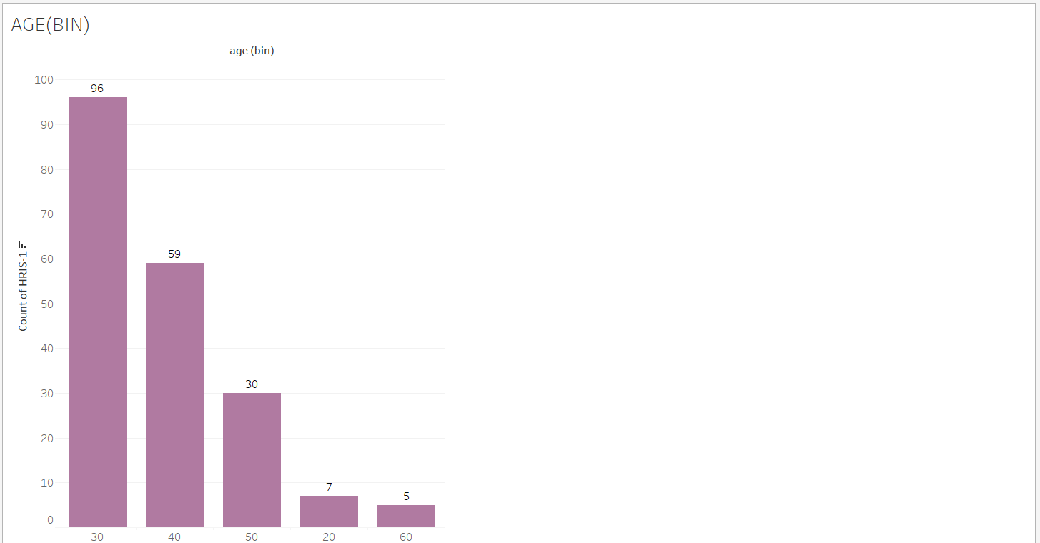

Insight:

The age group with most no of employees is 30-40 years with 96 employees followed by 40-50 years,20-30 years and then finally > 60 years with 59,30,7 and 5 employees

c. What are the demographics of the current employees by gender

1.Bring gender to rows and HRIS-1(count) to columns

2.Filter for active employees

3.Enable text labels

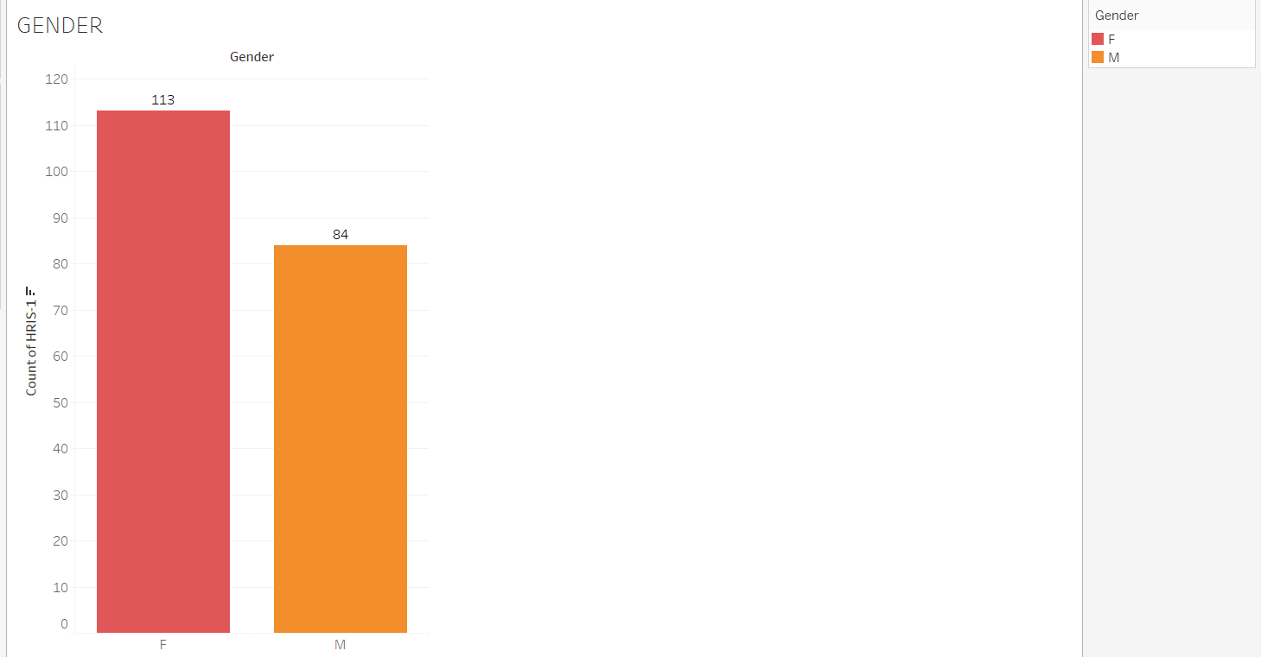

Insight:

The company has more females than male employees 113 and 84

d. What are the demographics of the current employees by marital status

1.Bring marital status to rows and HRIS-1(count) to columns

2.Filter for active employees

3.Enable text labels

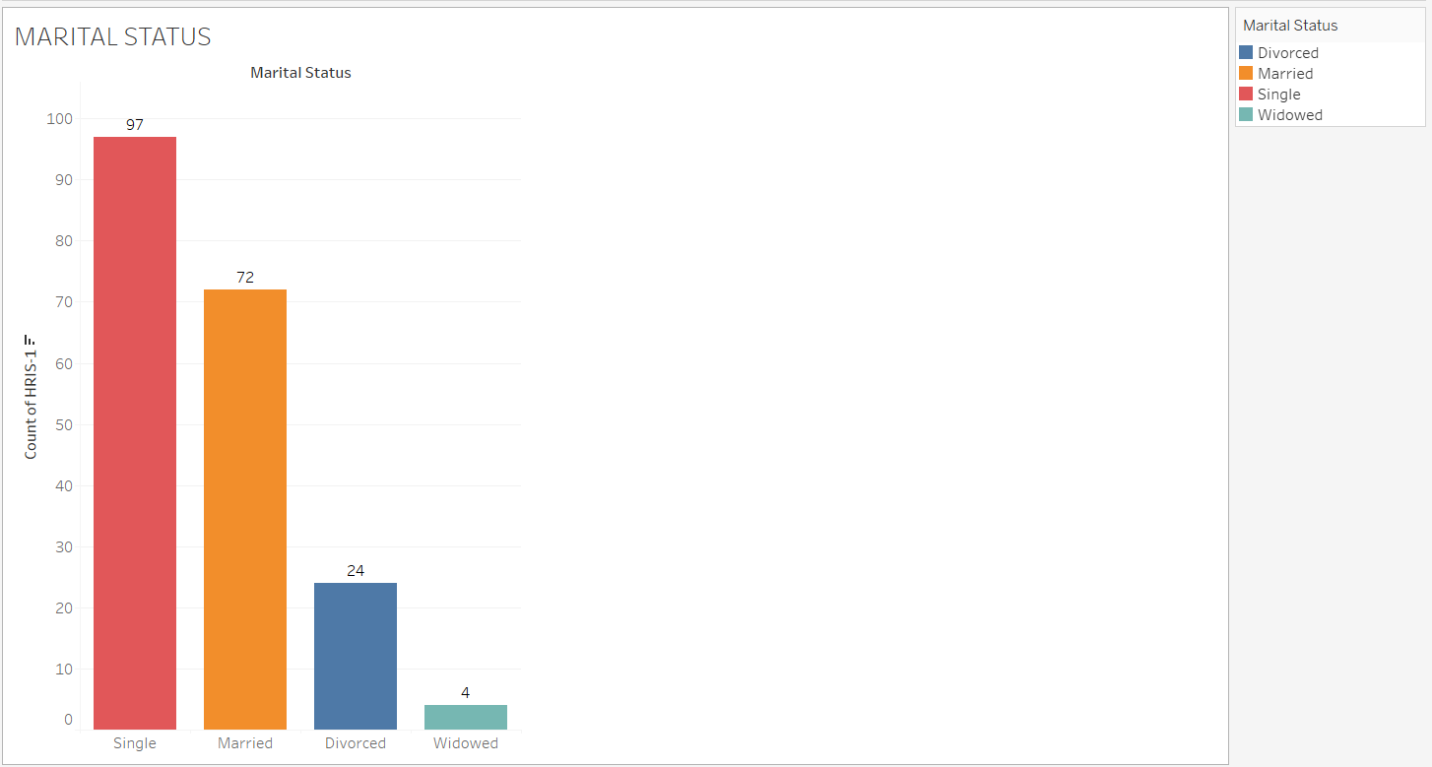

Insight:

Most of the employees are single 97, followed by married, divorce and widowed 72,24 and 4

2.Salary structure

a. What was the current total salary expense for each department

1.Bring dept to rows and salary to columns

2.Duplicate the salary field in the column and convert the aggregation to ‘average’

3.Filter for active employees and enable text

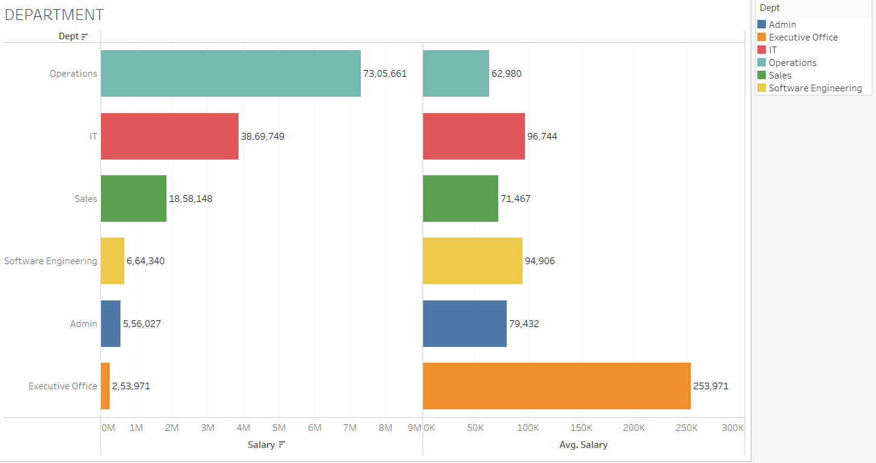

Insight:

Among all dept excluding executive office given it is the CEO the dept with average highest salary is IT and the dept with the lowest average salary is operation in terms of total salary the operation is on top because of the no of the employees in the dept

b. What is the salary structure by age

1.Bring the age(bin) to the column and salary to the row

2.Duplicate salary in the rows and convert aggregation to average

3.Filter for active employees and enable text labels

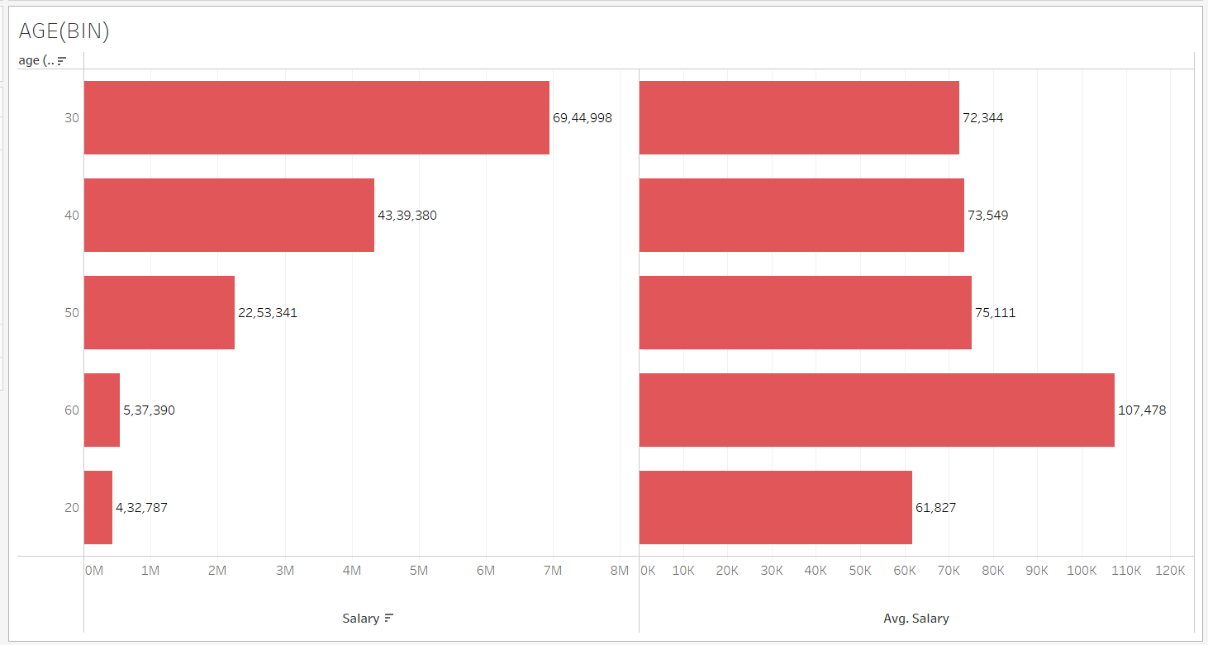

Insight:

In average salary, across all bins the salary levels were similar except

20-30 years bucket this is only because there are only few employees

in the bucket in terms of total expenses the highest expense is in the

30-40 years category because of no of employees in the group

c. What is the salary structure by gender

1.Bring gender to the rows and salary to the columns

2.Duplicate salary in the columns and convert the aggregation to show

Average

3.Filter for active employees and show text labels

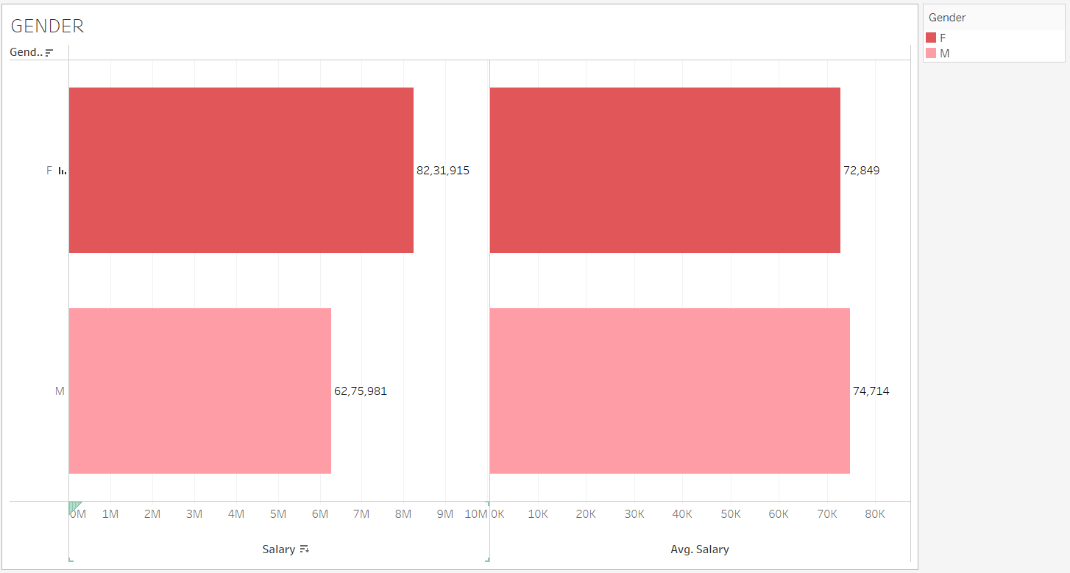

Insight:

More salary expense goes to the female gender mostly due to the number of female staffs in terms of the average salary the difference in the salary made by female staff in comparison with that of the male staff is about <$2000

d. What is the salary structure by marital status

1.Bring marital status to the rows and salary to the columns

2.Duplicate salary in the rows and convert the aggregation to show average

3.Filter for active employees and show the text labels

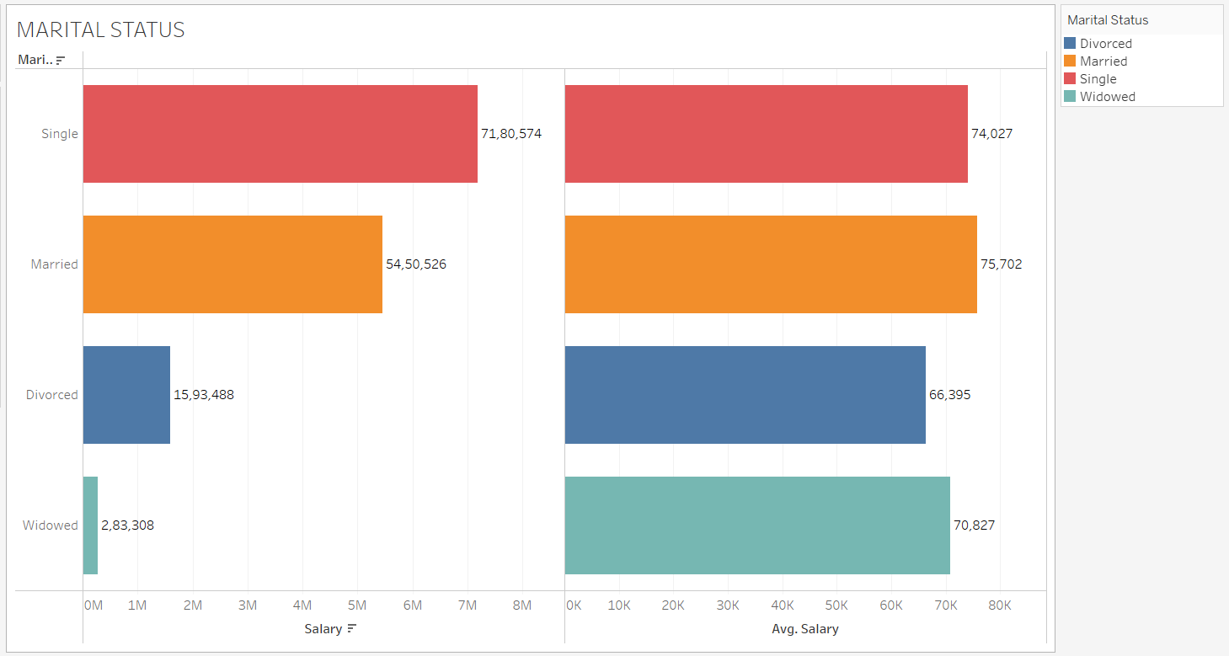

Insight:

It seems like the average salaries made by single and married employees were similar however the divorced employees made 8000 lesser this could possibly because this category has only few employees however given that there are 24 employees in this group we cannot disregard the difference in average salary